Make to Innovate Final Report
Josh DeLarm, Ethan Harstad, Josh Boyer, Alex Maxwell, CJ Monks, Nolan Van Rossum, Brian Hageman, Timothy Miner

May 3, 2013
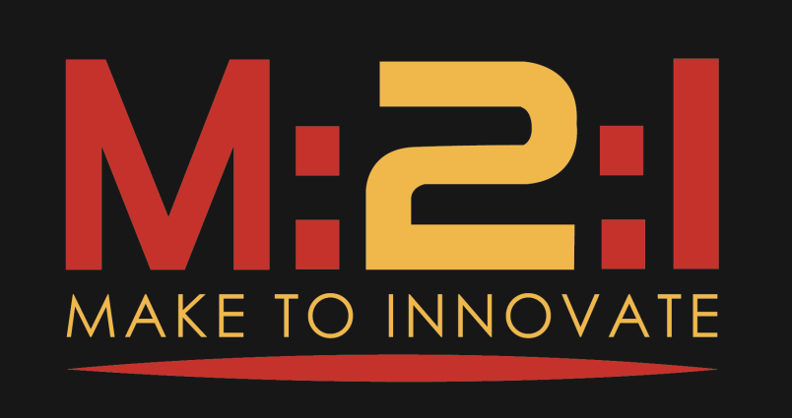

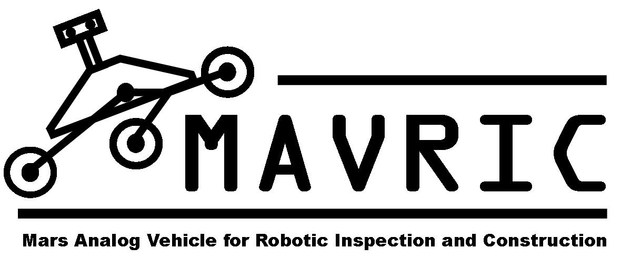

Abstract
This report details aspects of the student-led group called MAVRIC (Mars Analog Vehicle for Robotic Inspection and Construction). It covers the background of the project, goals of the project, as well as the tasks that the group is asked to complete. In addition, project milestones, current progress, and future plans can also be found in this report.

This final report is submitted in partial fulfillment for the Make to Innovate (M:2:I) program at Iowa State University in the Aerospace Engineering department and in part for their grade in AerE 290C or AerE 490E. The author(s) hereby state that the information submitted in this report is accurate to the best of their knowledge.

Contents
Make to Innovate Final Report 1
Contents 3
Part I — Overview 4
1 Background 4
2 Project Goals 4
2.1 Competition Goals 4
2.2 Project Goals 5
Part II—Project Definition 6
1 Project Milestones 6
Part III—Project Results 7
1 Finished items 7
1.1 Solidworks Model 7
1.2 Suspension Construction 7
1.3 Wheel Construction 8
1.4 Chassis Construction 9
1.5 Robotic Arm 10
1.6 Gearbox Design 11
Part IV—Conclusion 12
1 Future Work 12
1.1 Team changes 12
1.2 Future Goals 12

Part I — Overview
MAVRIC is a student lead project aimed at creating a simulated Mars rover for a competition held in Hanksville, Utah every summer. Students design, fabricate, and test the rover and various necessary sub-systems needed for a fully functioning rover. The project offers a unique opportunity to introduce engineers-in-training to the principles they will have to utilize on a daily basis in an industry setting. Communication skills, presentation skills, team working skills, as well as the design and fabrication skills learned while being part of this project are vital to the future success of the student engineers.

1 Background
MAVRIC has existed as a project of the Make to Innovate program (M2I) for going on roughly five years now. Throughout those years, there have been many iterations of rovers that encompassed different design ideas. The team of this year was a completely new team and wanted to take a new approach to the project. The idea was to change the way the project as a whole operated. Instead of doing a new rover each and every year, the idea was to create a platform that was so well designed and suited to the task at hand that future semesters could simply add to the rover and work towards increasing its performance.

2 Project Goals
MAVRIC has a couple sets of goals as a project. One set in specific is targeted to the rules of the competition and aims at overcoming those. The other set of goals targets what the current team wishes to improve over previous years in the area of design.

2.1 Competition Goals
The competition that MAVRIC is aimed at attending is called the University Rover Challenge (URC) and is put on by the Mars Society. Like any competition, there are rules and tasks that are required to be completed. MAVRIC is tasked to complete five tasks in total. These tasks are as follows:
• Task one is a presentation task in which the team is asked to put on a formal presentation describing the rover and its functionality, as well as the team and its structure.

• Task two requires the team to remotely operate the rover in order to obtain a subsurface soil sample from an area deemed by the team to contain biological life. The sample must then be tested in an onboard test as well as tested again at the command station to determine if any biological life exists in the sample.

• The third task, deemed the Astronaut Assistance Task, is aimed at testing the ability of the rover to drop off packages of various sizes to simulated Astronauts, given rough GPS coordinates. The rover will be required to carry up to 5 payloads, weighing a maximum of 6kg a piece.

• Equipment servicing is the fourth task that the rover must complete. This task involves using a robotic arm remotely to operate switches and levers in an order determined by a set of directions that will be posted near the task location. In addition, the rover must also be able to clean a solar panel that has simulated “electrostatically adhered dust” on its surface. The rover must then be able to test voltages across terminals in order to determine if the solar panel is “clean enough” to pass inspection.

• The fifth and final task involves being able to traverse terrain that the rover would encounter if actually on Mars. This task is set up so that the rover will encounter various terrains of varying difficulties along a predetermined path. To complete this task, the rover must successfully travers this terrain in the allotted time.

2.2 Project Goals
In addition to Competition goals, MAVRIC also holds a set of project-related goals. These goals are what the group as a whole would like to see in the project. These elements go beyond the requirements of the competition and encompass the ideals that make up MAVRIC.
- Design a rover capable of doing all the tasks required by the URC.
- Create a rover platform that can be used for multiple years rather than just one.
- Create a learning opportunity for members that will better prepare them for the job market.
- Strengthen skills in member communications, teamwork, and leadership.

Part II—Project Definition
Specifically, MAVRIC is tasked with designing a rover with components and sub-systems that satisfy the requirements of the URC tasks. These include being able to obtain a subsurface soil sample, being able to traverse rough terrain, being able to manipulate switches and buttons as well as clean a solar panel, and being able to drop off payloads to simulated astronauts. In addition, MAVRIC is tasked at an internal level to provide a positive learning environment for student engineers as well as strengthen and develop skills they will need in the future.

1 Project Milestones
MAVRIC, as a team, has determined a few milestones to gauge the accomplishment of the team goals.
- Fully Design Rover – This is the logical first step in completing a large-scale design of this nature. The basic ideas must be talked through and sketched out. Upon completion of that, 3D models need to be made in order to ensure all parts and systems are working in unison, the way they were designed to.
- Complete Chassis Construction – The chassis in this case refers to the suspension system in conjunction with the chassis itself. These two sub-systems make up the platform on which everything else is mounted and therefore are the first sub-systems that need to be implemented.
- Driving Chassis – Driving is arguably one of the most important aspects of the entire project. Without the ability to move, the rest of the sub-systems cannot function as designed. In order to drive, electronics need to be integrated with the mechanical systems and in addition have to work together correctly.
- Fully Integrated Sub-systems – The tasks that MAVRIC’s rover is to complete require several specialized tools. Each tool or assembly of tools makes up a sub-system. These sub-systems are as follows: the payload deployment mechanism, the robotic arm, the end effector, the soil sampling attachment, as well as the solar panel cleaning tool. It is tantamount to the group’s success at competition that each sub-system works as designed and has had adequate testing.
- Testing – In addition to the testing necessary for the sub-systems, the entire rover needs to be tested. This includes being able to use all sub-systems in a manner consistent with design criteria, being able to drive in addition to using tools, as well as being able to do all this remotely from the remote command station.
- Attend Competition – This is the purpose that the rover was designed, built, and tested for. This signifies the culmination of successes from all the previous goals, and thusly means the group did what it set out to do.

Part III—Project Results

1 Finished items

1.1 Solidworks Model
The first step was to fully design a rover on paper and then transfer that into a 3D model. Solidworks was used to achieve this. Each system was designed with appropriate measurements in order to make a “full scale” 3D model off of which measurements could be taken. This model allowed the group to determine the effectiveness of each design and to ensure that each part worked together with all other parts in the assembly.

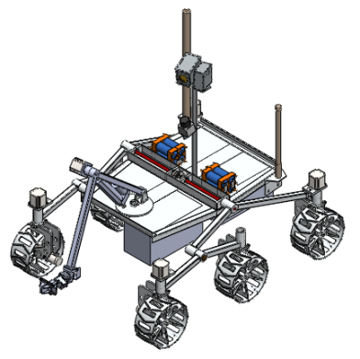
Figure 1- Solidworks Model of MAVRIC. This was the first step towards creating the team’s Mars rover.

1.2 Suspension Construction
The Rocker-Bogie suspension was chosen for its maneuverability and overall lighter weight than the previous years’ tracks. The suspension is made of 1” square tubing with 1/8” wall thickness. The suspension was designed to allow for enough ground clearance to mount and deploy the payloads from the bottom of the rover. In addition, the ground clearance also will allow for larger obstacles to be traversed. Pins were added at the joint between the suspension and the chassis to allow for quick breakdown and reassembly. The Bogies, the front, smaller portion of the suspension, were designed to be identical front to back, which allows the right and left Bogies to be used interchangeably. This allows for a single replacement part to be made and then used on either side in the event of a broken Bogie.

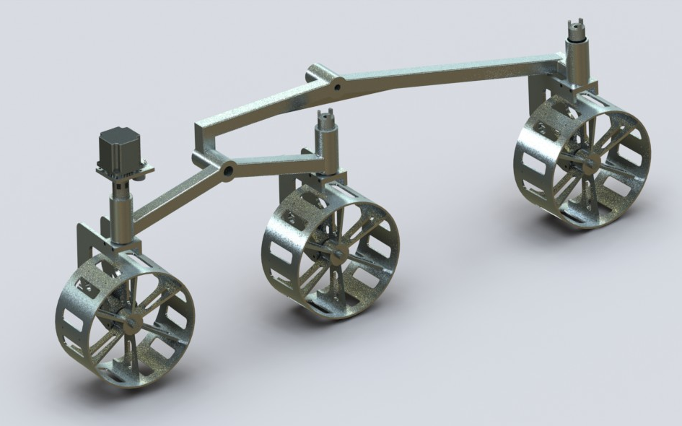
Figure 2- Solidworks model of MAVRIC's suspension.

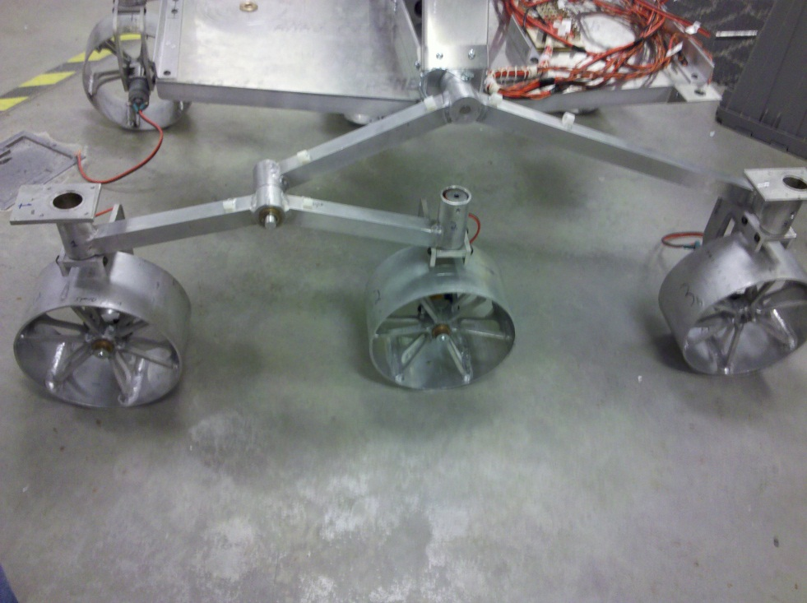
Figure 3- The final construction of MAVRIC's suspension system.

1.3 Wheel Construction
The wheels were manufactured by the team. The decision was made to manufacture wheels when the preferred style of wheel was not available commercially. A Solidworks model was created to help simulate fabrication steps and cost. Solidworks also allowed for an estimate of the wheel’s weight. The model estimated the wheels at .81 kg. The actual wheels turned out to be .86 kg. This weight was comparable to the weight of commercial versions. The cost of fabricating the wheels was substantially less, and thus was a more economical approach.

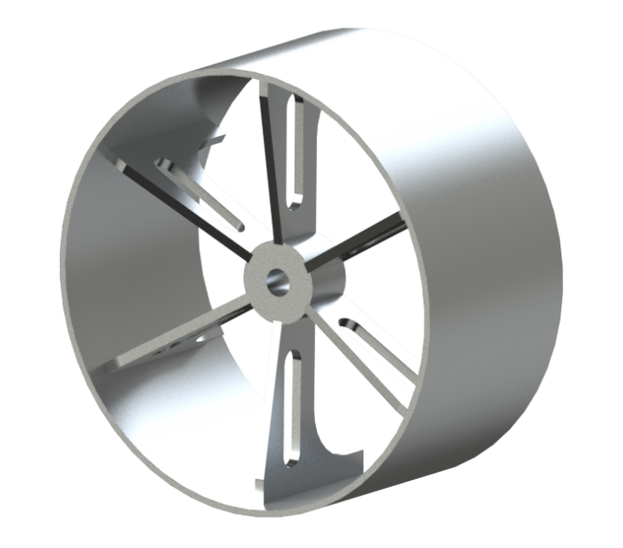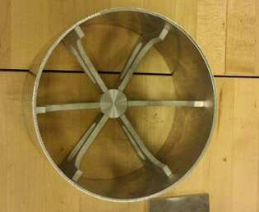
Figure 4 - Solidworks model of the wheel used to determine cut out sizes.
Figure 5 – Beginning stages of fabrication on the wheel.

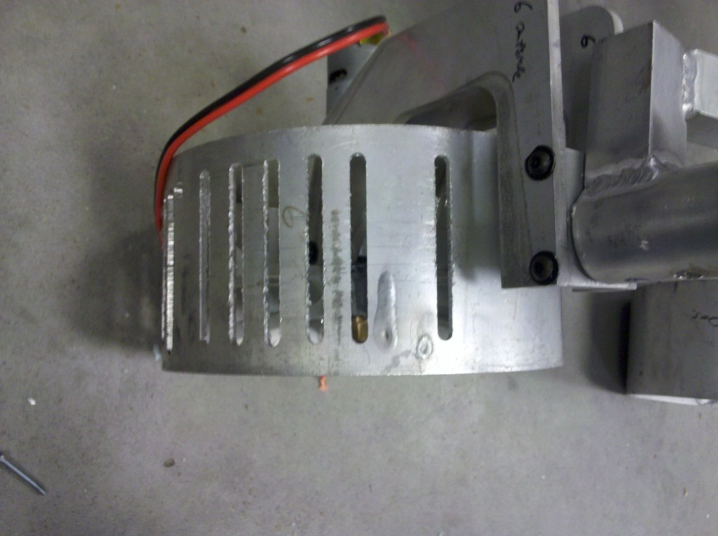
Fabrication of the wheels involved purchasing a length of 8” diameter aluminum tube with wall thickness of 1/8”. This was cut into 4” sections that would make up the body of the wheels. The inner spokes were cut out of 1/4” plate aluminum using a water jet. The inner hub was manufactured out of 1 1/2” round stock. The spokes were then set in place and welded by the team. Welding weight accounts for the differential in weight between the Solidworks model and the actual wheel.

Slots will be cut into the wheels to accomplish two things. The first of which is to lighten the overall weight of the wheels. With an allowable mass of 50Kg, weight must be conserved wherever possible. The second of these reasons is to add traction to the wheel. By cutting slots into the outer surface of the wheel, differences in height of the wheel are introduce, thus creating traction. If, during testing, additional traction is necessary, strips of tread will be attached on the outer surface to introduce even more variation in the surface. In addition, a rubberized coating is intended to be used on the outer surface to allow for grip on smooth and hard surfaces. This will add weight but will provide a great benefit in overall traction.
Figure 6 – Slots are cut into the wheel to reduce weight and to increase overall traction.

1.4 Chassis Construction
The chassis of the rover is created by the intersection of two aluminum C-channel that are bolted together. These channels make up the rigid structure that everything on the rover is mounted to. The outside perimeter of the chassis is made up of aluminum angle. This provides a solid surface for the sheet metal plates to be mounted to, and allows for more rigidity. All of the larger components of the rover are mounted to the C-channel directly, ensuring a strong mounting point. The arm, for instance, is mounted on the front of the rover, directly to the C-channel that runs from the front to the back. The differential that the suspension needs to function is mounted in the channel that runs from the left side of the rover to the right. In addition, the camera mount, which can be seen in the figure, is also mounted to the chassis via the channels.
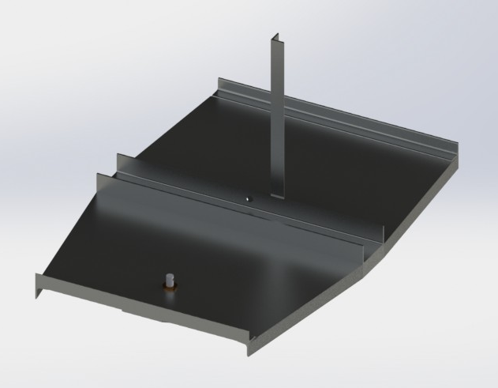
The actual chassis construction can be seen to the left. The entire chassis construction is bolted together to allow for easy repair in the event of a broken section. In the cross C-channel the differential setup is visible. It consists of a series of blocks with press fit bearings in order to allow for low friction rotation. The differential consists of three miter gears that, when one side of the suspension is lifted, the other is pushed down to balance itself.
Figure 7 – The model of the chassis was necessary in order to plan out all of the dimensions and to ensure that all the parts would fit accordingly.

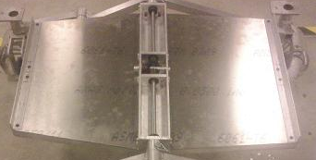

Figure 8 – The model of the chassis was necessary in order to plan out all of the dimensions and to ensure that all the parts would fit accordingly.
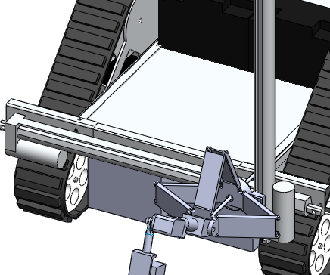

1.5 Robotic Arm
The URC competition has several tasks that require the use of a robotic arm. The equipment servicing task is the most intensive of these tasks. The team will be asked to manipulate a series of switches, buttons, and levers using only the robotic arm. In addition, the team is asked to clean a solar panel using their arm. Since this all takes place in one section of the competition, there is no time allowed for reconfiguring the rover. This means that all the parts necessary to complete the task must be on the rover at the start of the event. A secondary task also makes use of the robotic arm. The soil sampling task will use the arm and a mounted auger bit to drill into the soil and collect a sub-surface sample.
Figure 9 – The Cartesian-style arm can be seen on the old rover.
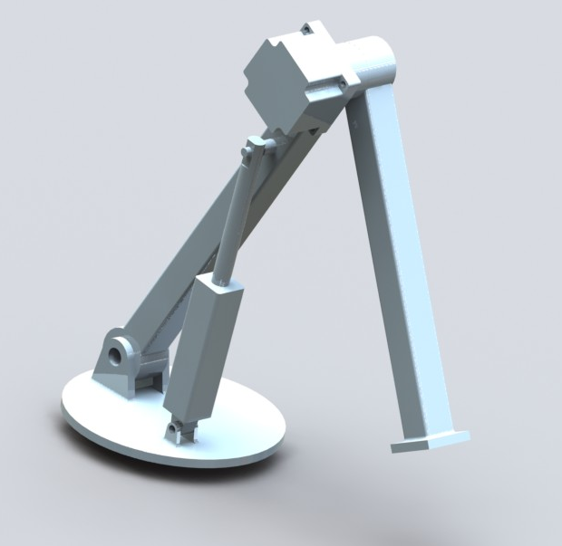
Due to its heavy use in the URC competition, as well as the tasks that it is asked to do, it was decided to change the arm design of the rover to allow for completion of the previously mentioned tasks.
The previous arm design was based off a Cartesian style movement system. Two electric linear actuators would move the arm in the X-Y plane. Z-axis movement was accomplished by an extension device. The tools were then attached to the end of the extension device in order to complete the necessary tasks.
Due to a relatively unstable initial design, weight concerns, and a desire to have more articulated movement, it was decided to redesign the entire arm. The new arm design allows for a larger range of motion as well as is more stable. It makes use of a linear actuator to move the lower portion of the arm. The upper portion of the arm is actuated by a stepper motor and a gearbox.
Figure 10 – The new version arm allows for a large range of motion as well as increased stability.

1.6 Gearbox Design
During the fabrication of the suspension, it became apparent that the stepper motors that were to be attached to the turning wheels were not going to produce enough torque to steer the rover. It was decided to design and build a gearbox. The gearbox uses a cycloidal profile to create a gear ratio and thus increases the amount of torque our motors can deliver to the wheels.
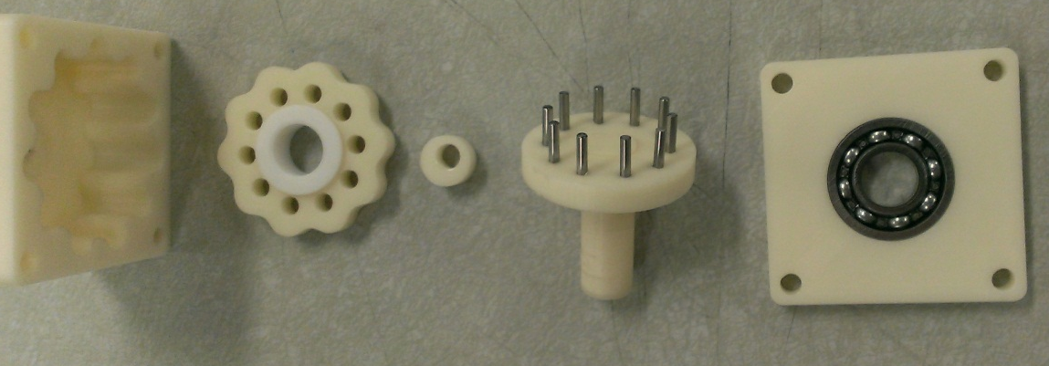

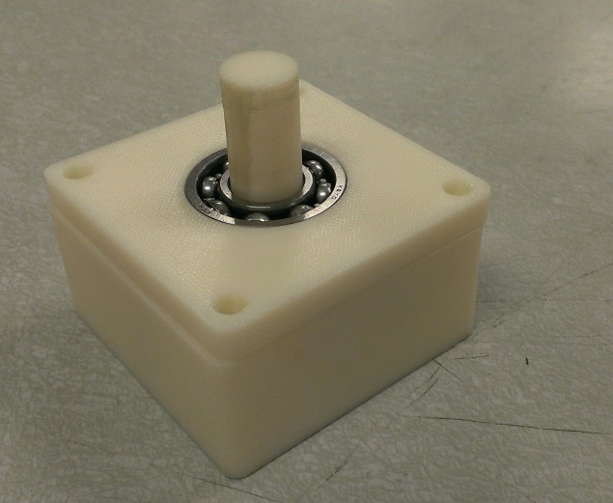
Figures 11- 13 – The gearbox was designed using simple parts to keep fabrication easy. In addition, it was designed to mount directly to the stepper motors, making everything more compact.

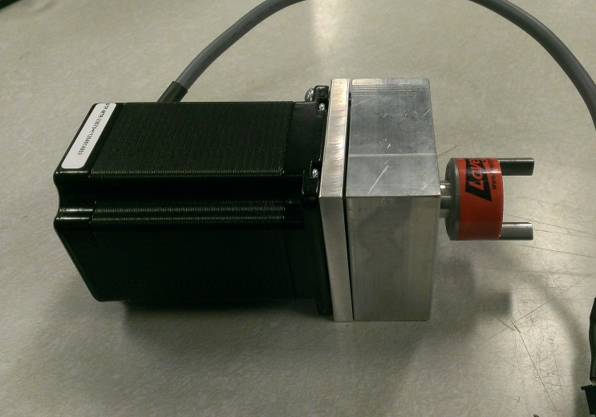

Part IV—Conclusion
MAVRIC as a project saw a whole new team at the beginning of the year. Naturally, with a new team and new leader, there will be some problems that have to be worked out. The team this year was relatively young, meaning that there were many more freshman and sophomores than juniors and seniors and members were rather inexperienced at fabricating. A lot of time was spent orienting members and training members in fabricating and designing practices. In one way, time was lost in fabricating parts for the rover, however, MAVRIC is not a project solely aimed at building a rover. Part of MAVRIC’s goal is to develop skills in members that they can use later in life. In this aspect, MAVRIC exceeded. In essence, time was spent building human capitol rather than fabricating towards the beginning of the year. Though time was spent doing this, the group still managed to get a lot of machining and fabricating done on the rover. The team spent the remainder of the year working on fabricating the components of the rover. Due to budget restrictions, most things were manufactured by the team. This process took longer than expected, but due to the budget limitations, was deemed necessary.
Electronics, as it has been in the past, became a problem area. The team only had two electronics members to design and code all the necessary electronics. Due to inexperience in electronics with members from the rest of the team, no one was able to help the electronics team get things accomplished. Several important systems did end up getting designed and completed by the diligent work of our electrical engineers, however driving and full functionality of the rover was not accomplished.
Because of the time constraints, deficiencies in electronics, and a plethora of manufacturing delays and other forms of delays, MAVRIC was not able to make it to competition this year. However, the work that has been accomplished has been done well and can be reused. The rover is almost mechanically done, and due to this, can also be reused. The rover design, overall, is a strong design and will create a great platform for work to commence next year.

1 Future Work
Future designs and plans are in place that the team will implement over the coming years. Not only do these plans revolve around the rover itself, but also around the team. The rover has room to be improved as does the team.

1.1 Team changes
This last year has been a great learning opportunity and has given everyone on MAVRIC an idea of changes that can be made in the future. These changes will allow the group to function more fluidly and productively. One such change will be the structure of the meetings. Previously, biweekly meetings were aimed at fabricating and being used to get tasks done. This, in theory is a great idea. It became apparent, however, that without an actual structured meeting in which to orient everyone, members were becoming lost and unsure of what they were to do. Because of this, it has been decided to have one meeting at the beginning of the week in which everyone attends and gets a list of tasks to complete and a timeline in which to complete them. A second meeting will be a fabrication meeting and will be used as time to accomplish the tasks set out at the beginning of the week. In addition to these times, members will be expected to put in additional time in order to complete their required tasks. These changes should allow the group to accomplish more as a whole and will help to avoid the situation that arose this year, namely that the group ran out of time to finish the rover.

1.2 Future Goals
Goals for the future of MAVRIC have also been laid out. The design that has been created over the last year is a very strong, versatile one. Having this type of platform will allow for more time to be devoted to sub-systems and further developing and testing everything. Future semesters will be able to build off the platform that is already done and simply add to it or modify it. In addition, with a stable platform to build off of, more time can be devoted in the future to electronic applications such as autonomous maneuverability.
As for short-term plans, it is planned that time will be put in over the summer to get the rover driving. The coming fall semester will be devoted to finishing the rover and all of the sub-systems. This will be a chance to fine-tune all of the sub-systems in order to make sure they are functioning exactly as designed. The spring semester will be devoted to testing and upgrading as many components as possible. This will not only include mechanical components but will also include electronic components and programming as well.
Overall, there exists a fair amount of goals for the coming years’ members to complete. This will allow future members to have an idea of where the project can go and what they can do to make that happen. The work that has already been done will create a stepping stone towards the ultimate goal of developing the best possible rover to take to competition.

